**JP Morgan Internship**

Mentor: Gabrielle Chester

ABL Mentor: Sophie

Day 1:

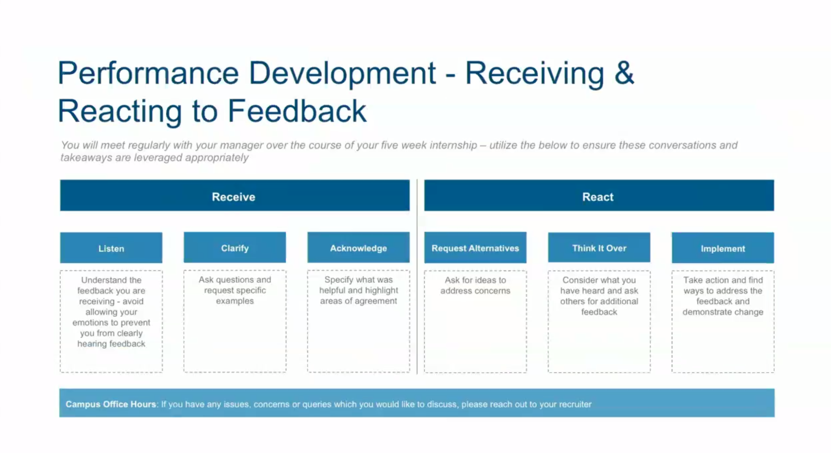

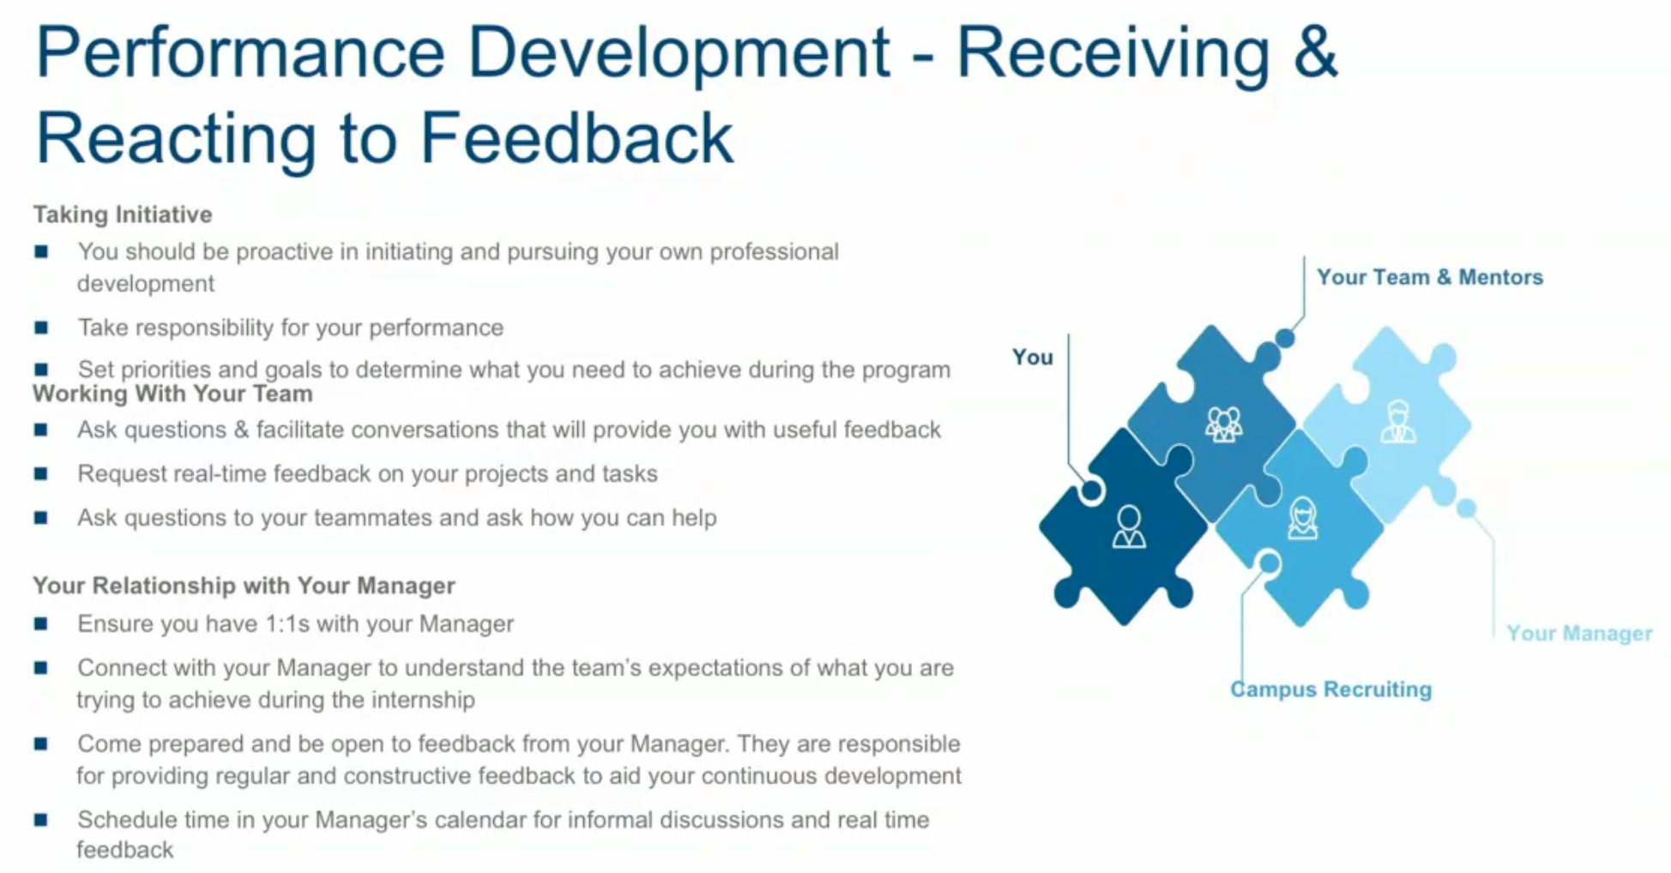

* Any piece of work done, ask for feedback!!

Business principles:

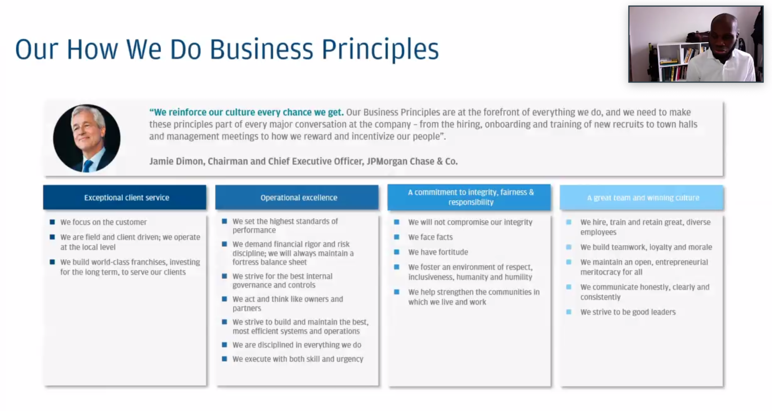

Samik Chandarana, MD -- Head of CIB Data & Analytics, Applied AI & Machine Learning

SOCIAL GOOD:

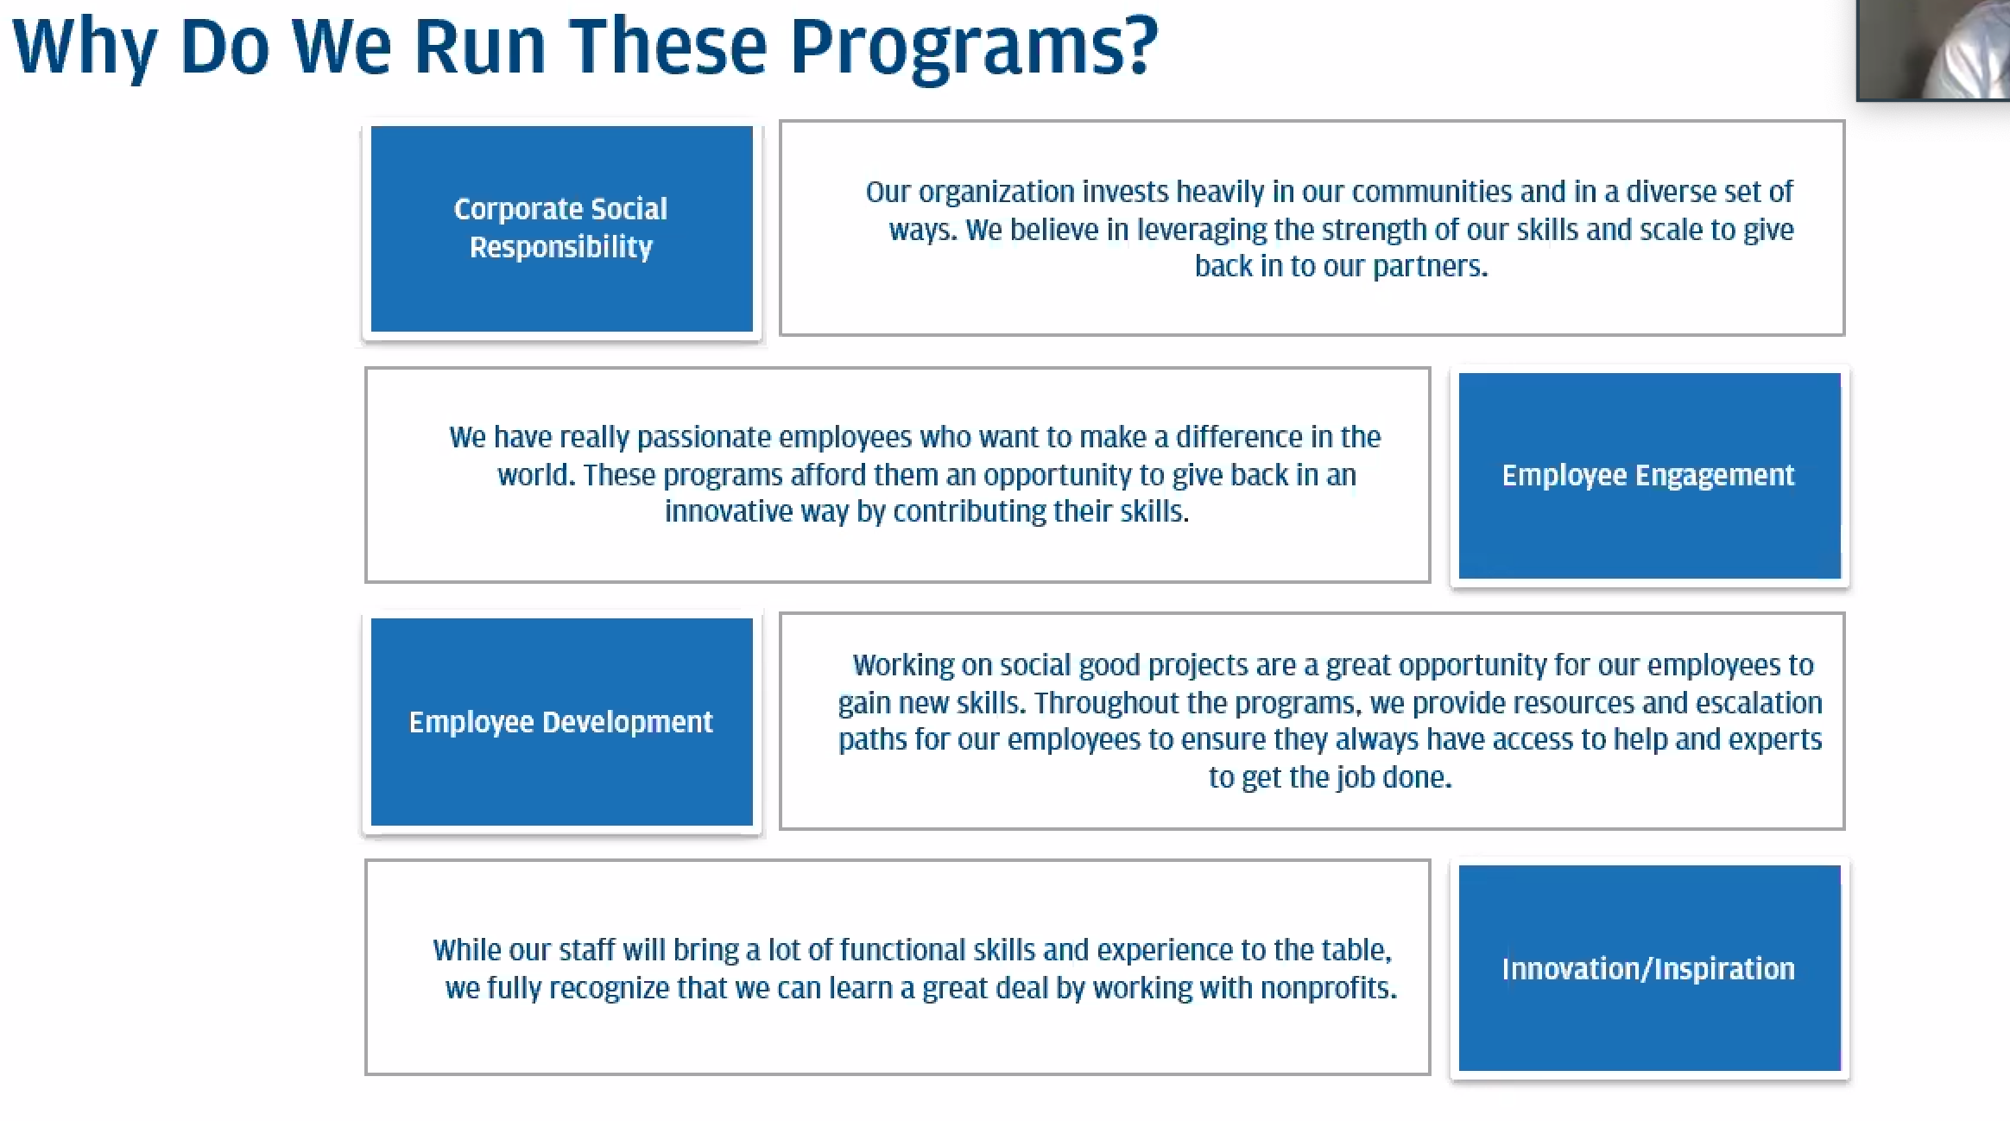

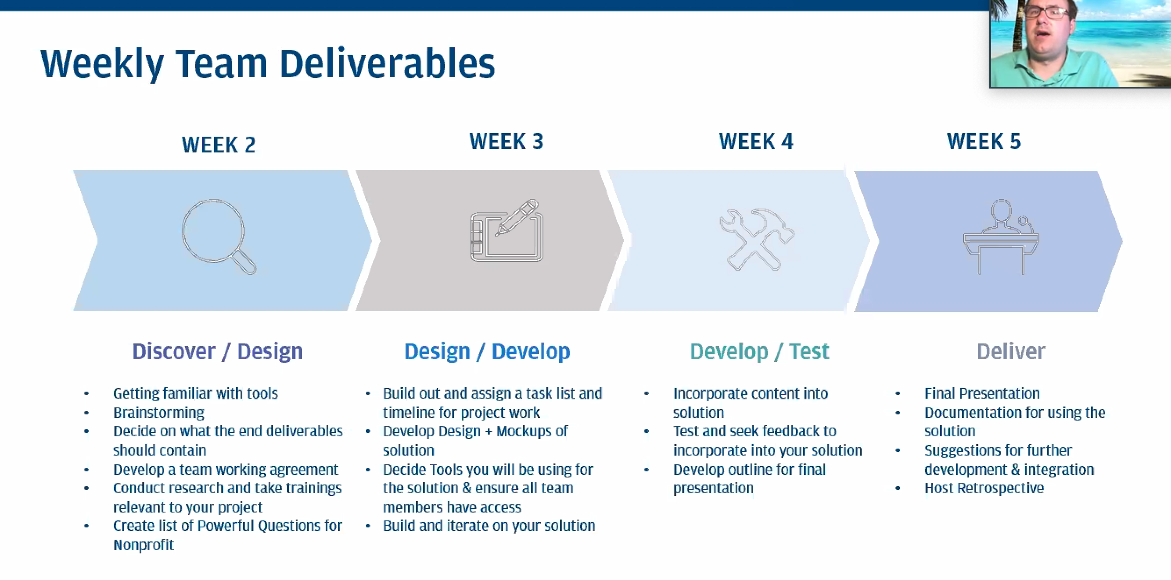

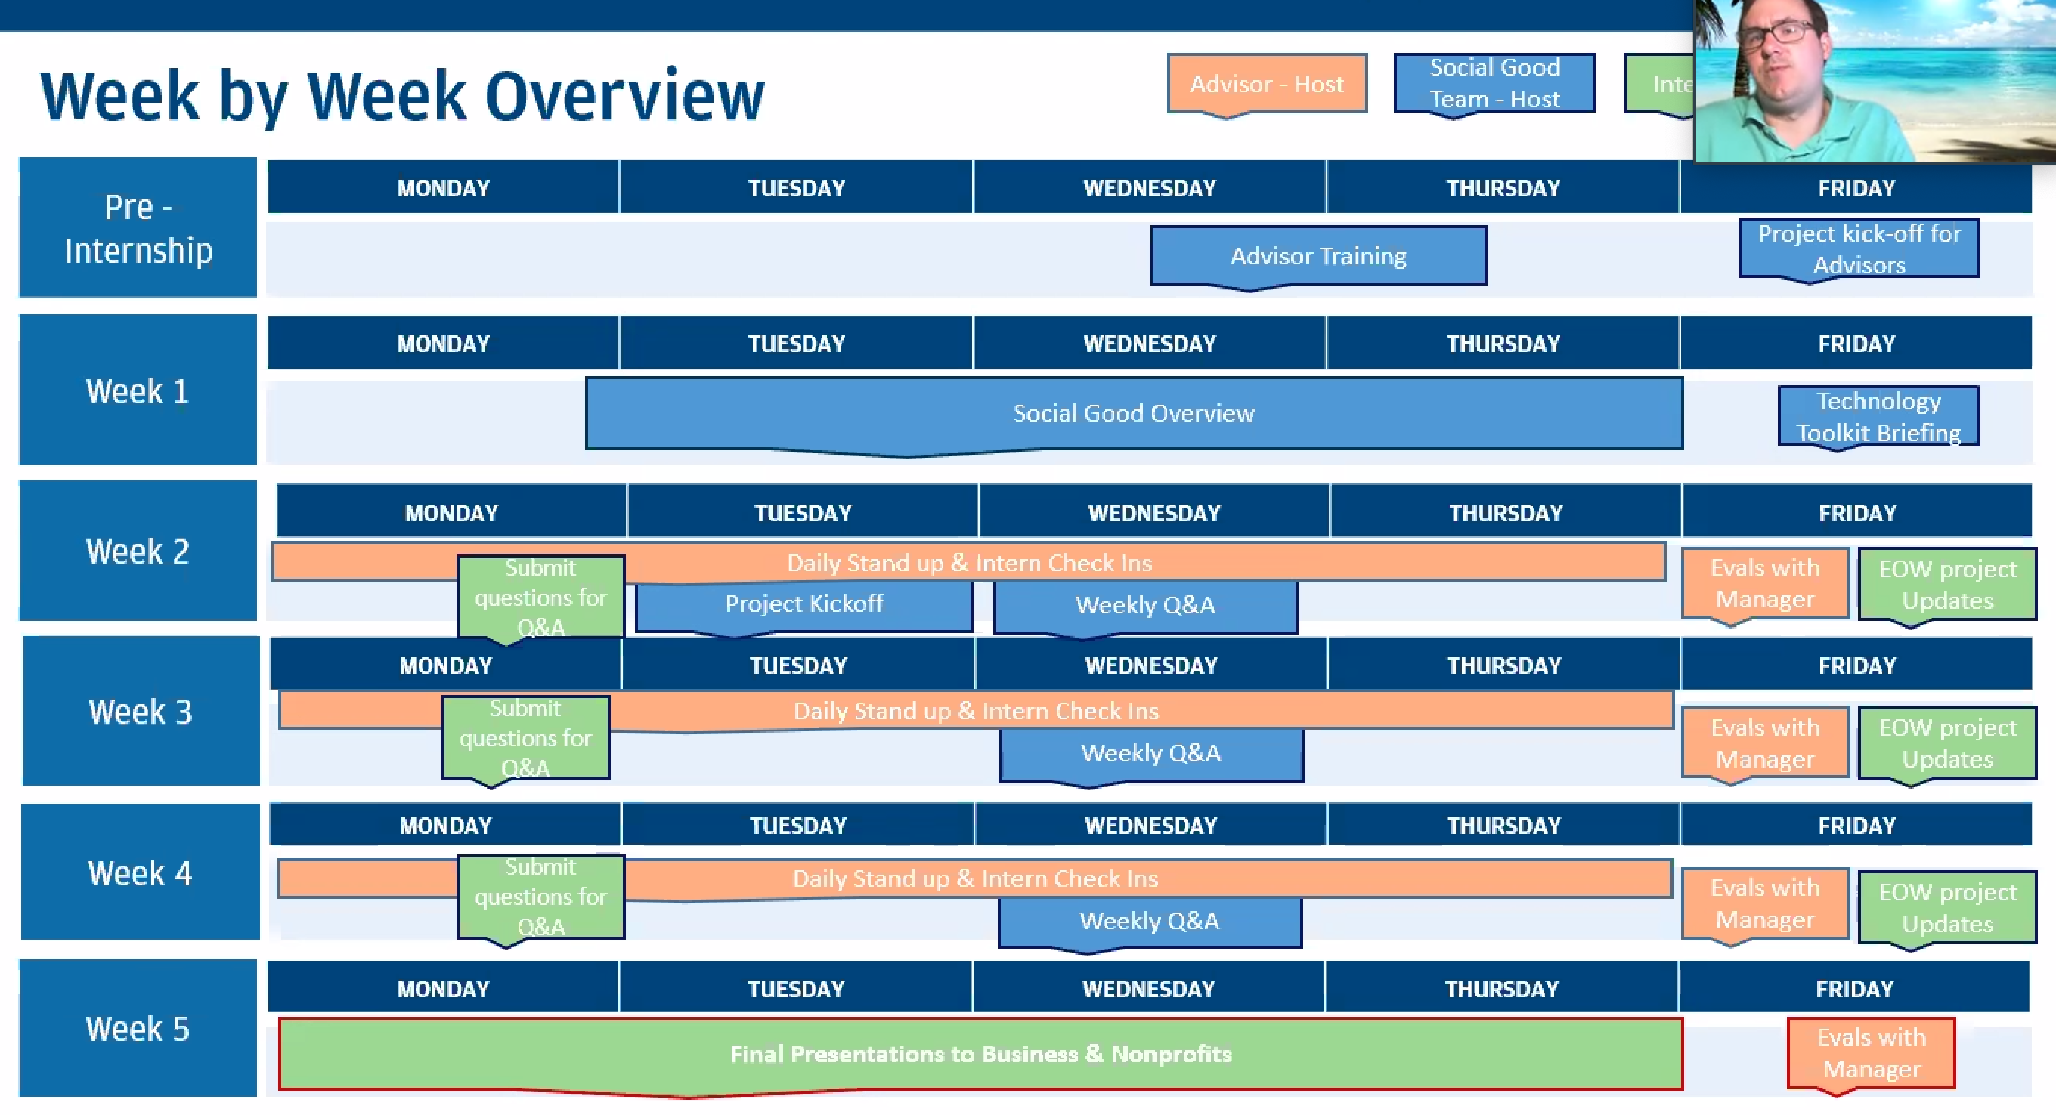

8th Jul: Meeting with advisors

* Write down everyday: what you did, what you need to work on next and any blockers. Keep a diary basically.
* Learn as much as you can about the charity, to generate ideas etc. Must have ideas before meeting on tues.

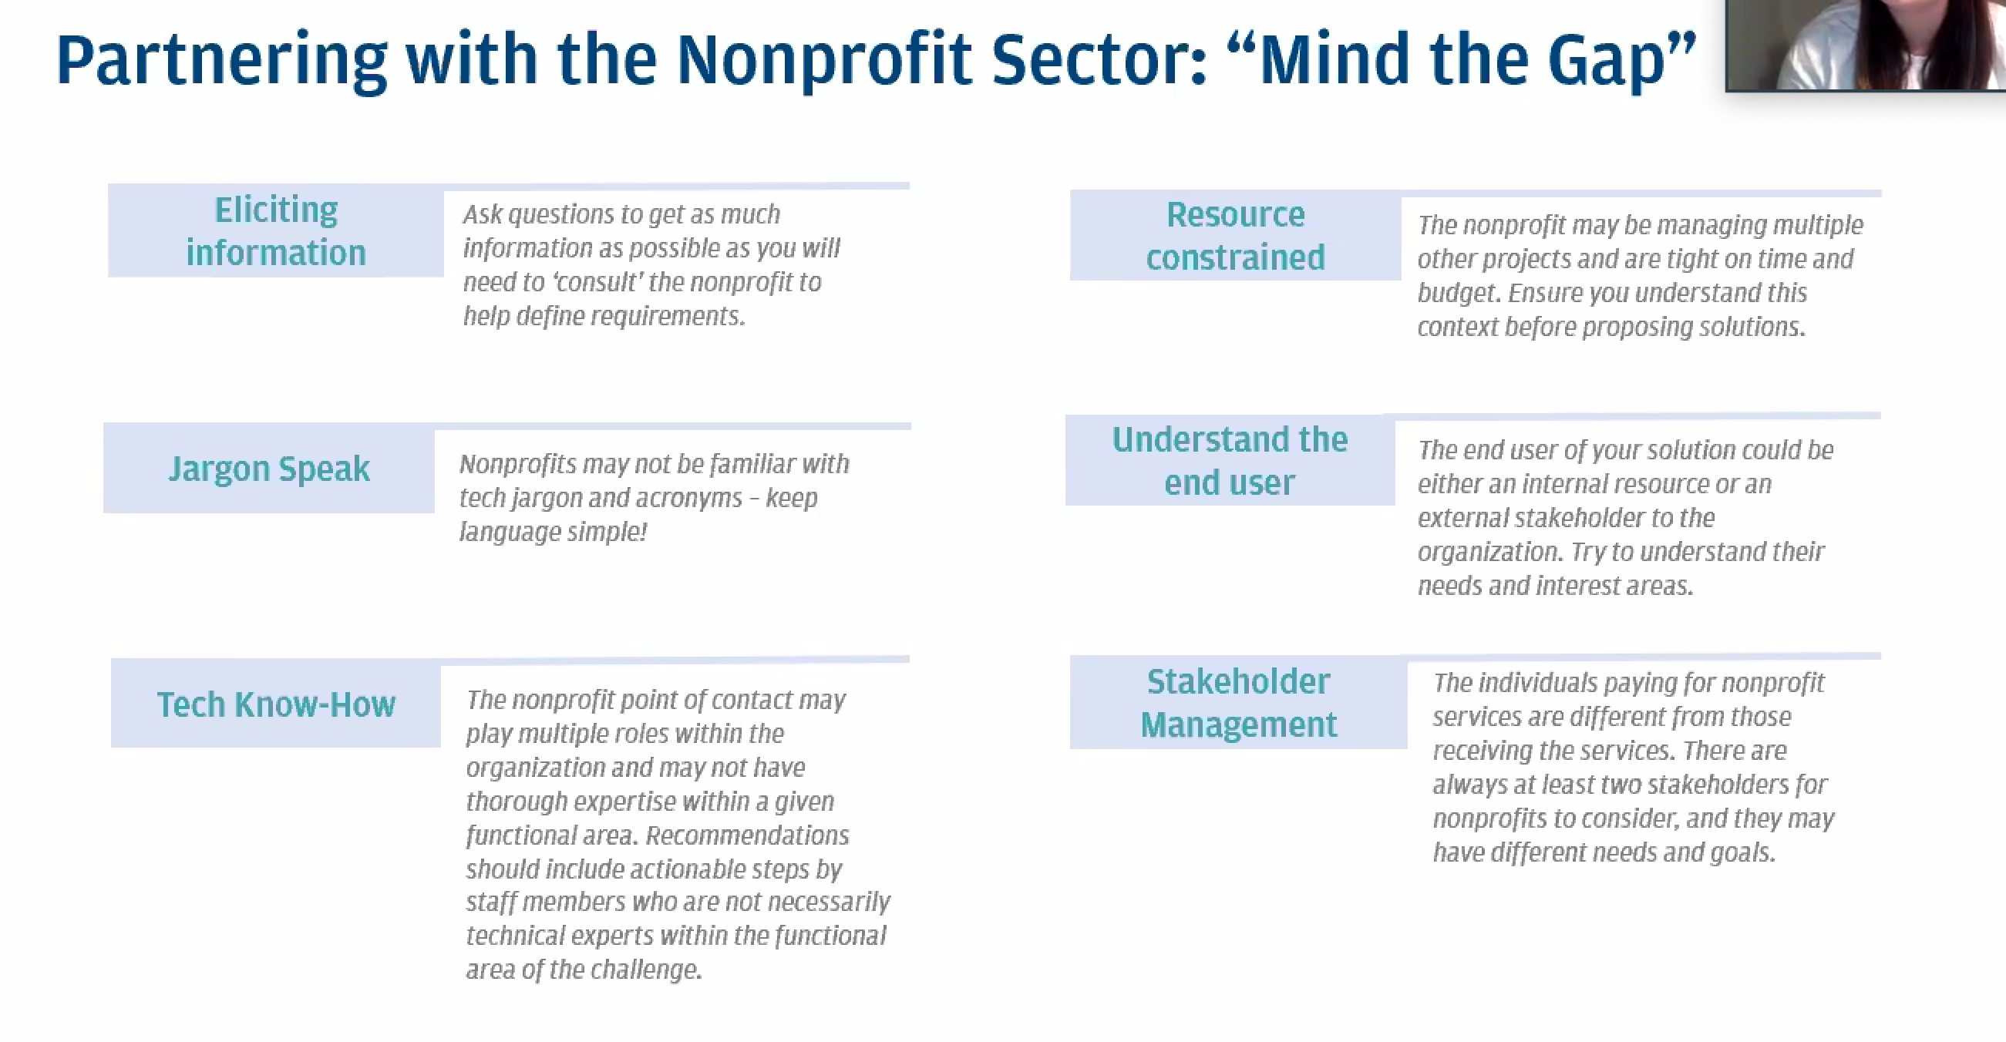

**Week 1:**

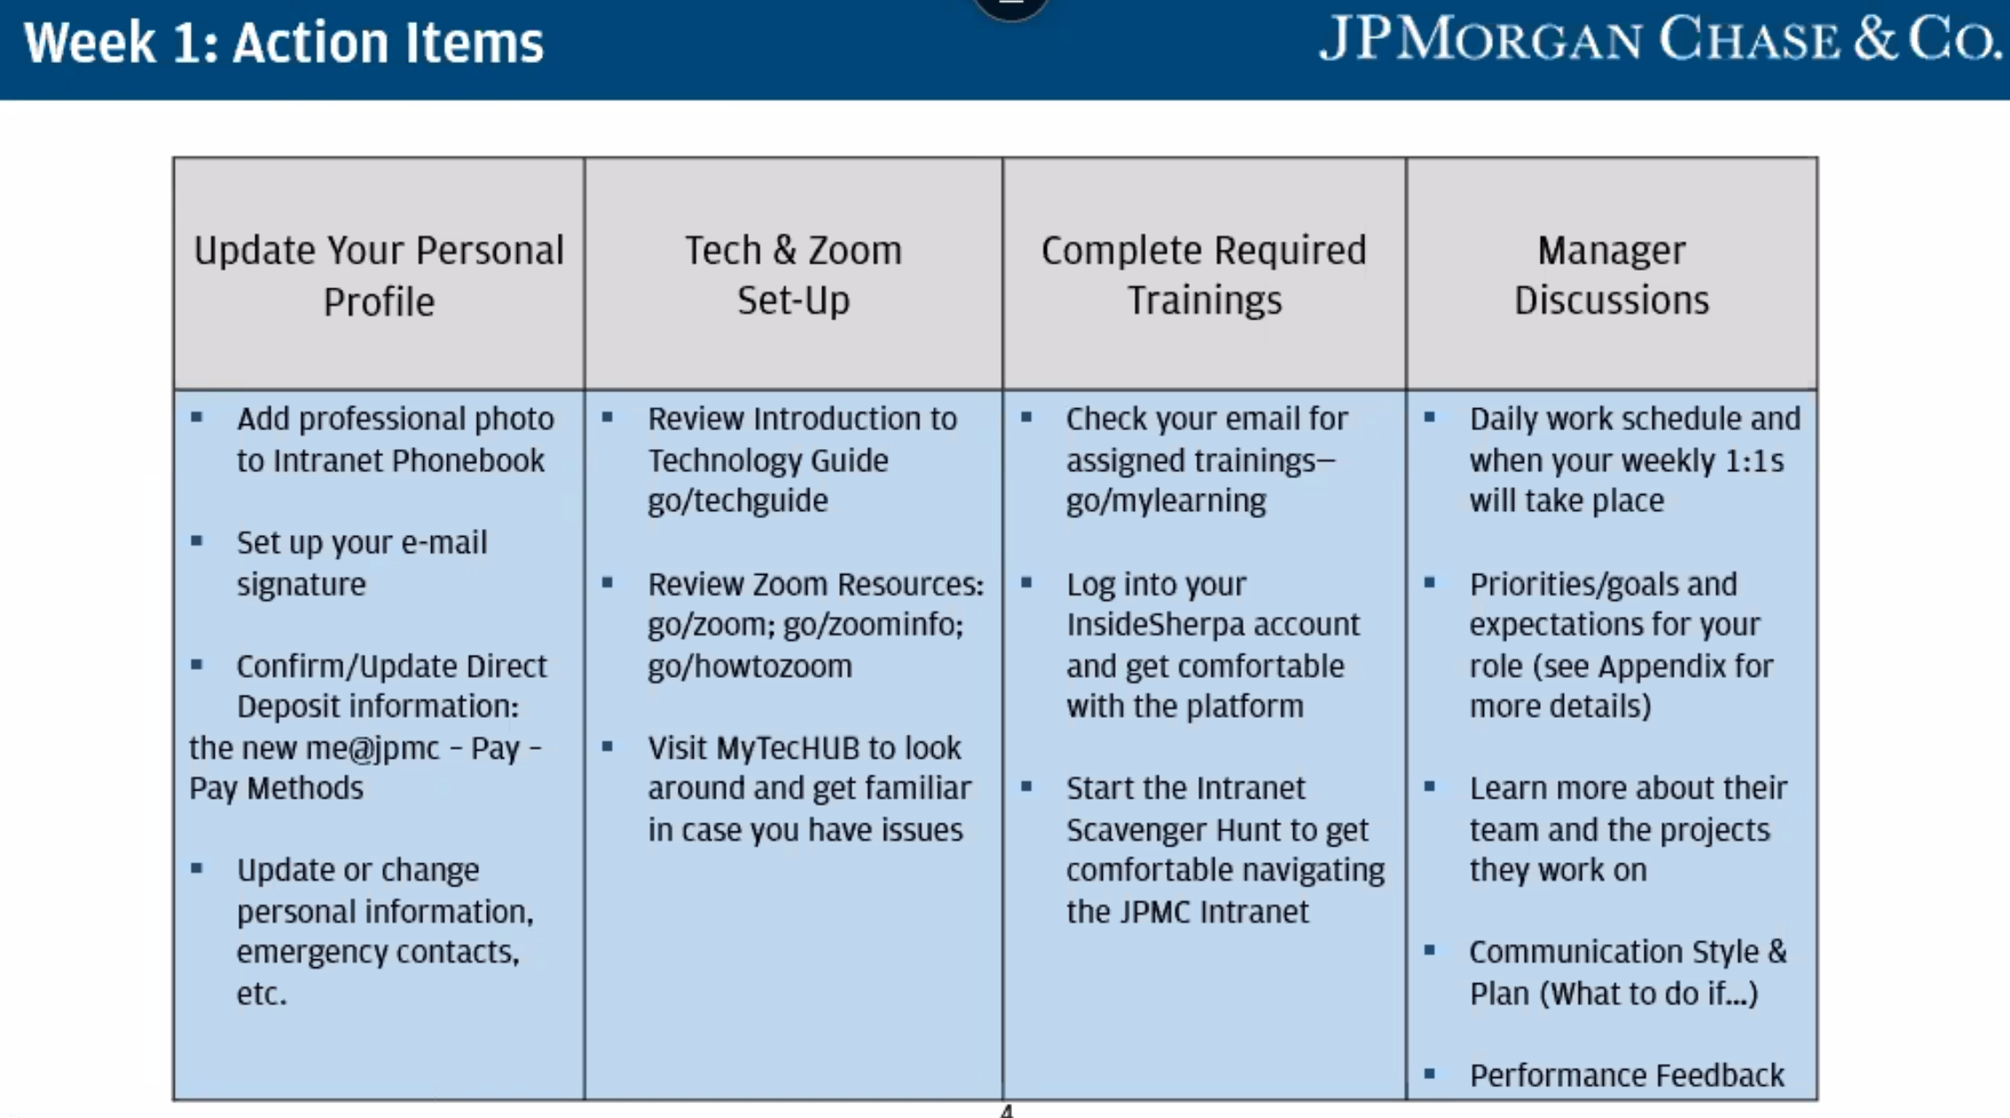

* **Must check weekly newsletter**
* **me@JPMC – update profile, payslips, assigned learning**

**Week 2:**

* **NEED TO SORT OUT PITCH PRO**
* **Daily StandUp #2: Stanisaw suggested Balsamiq wireframes.**

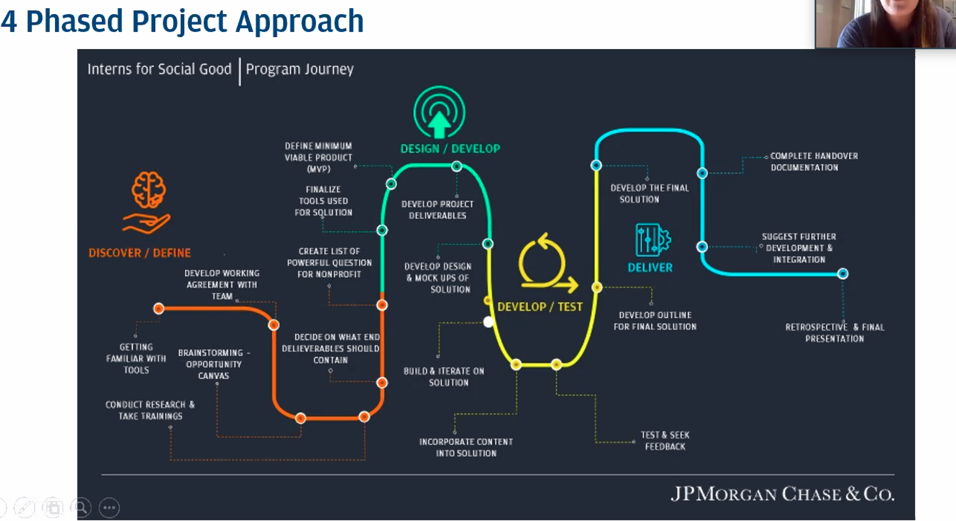

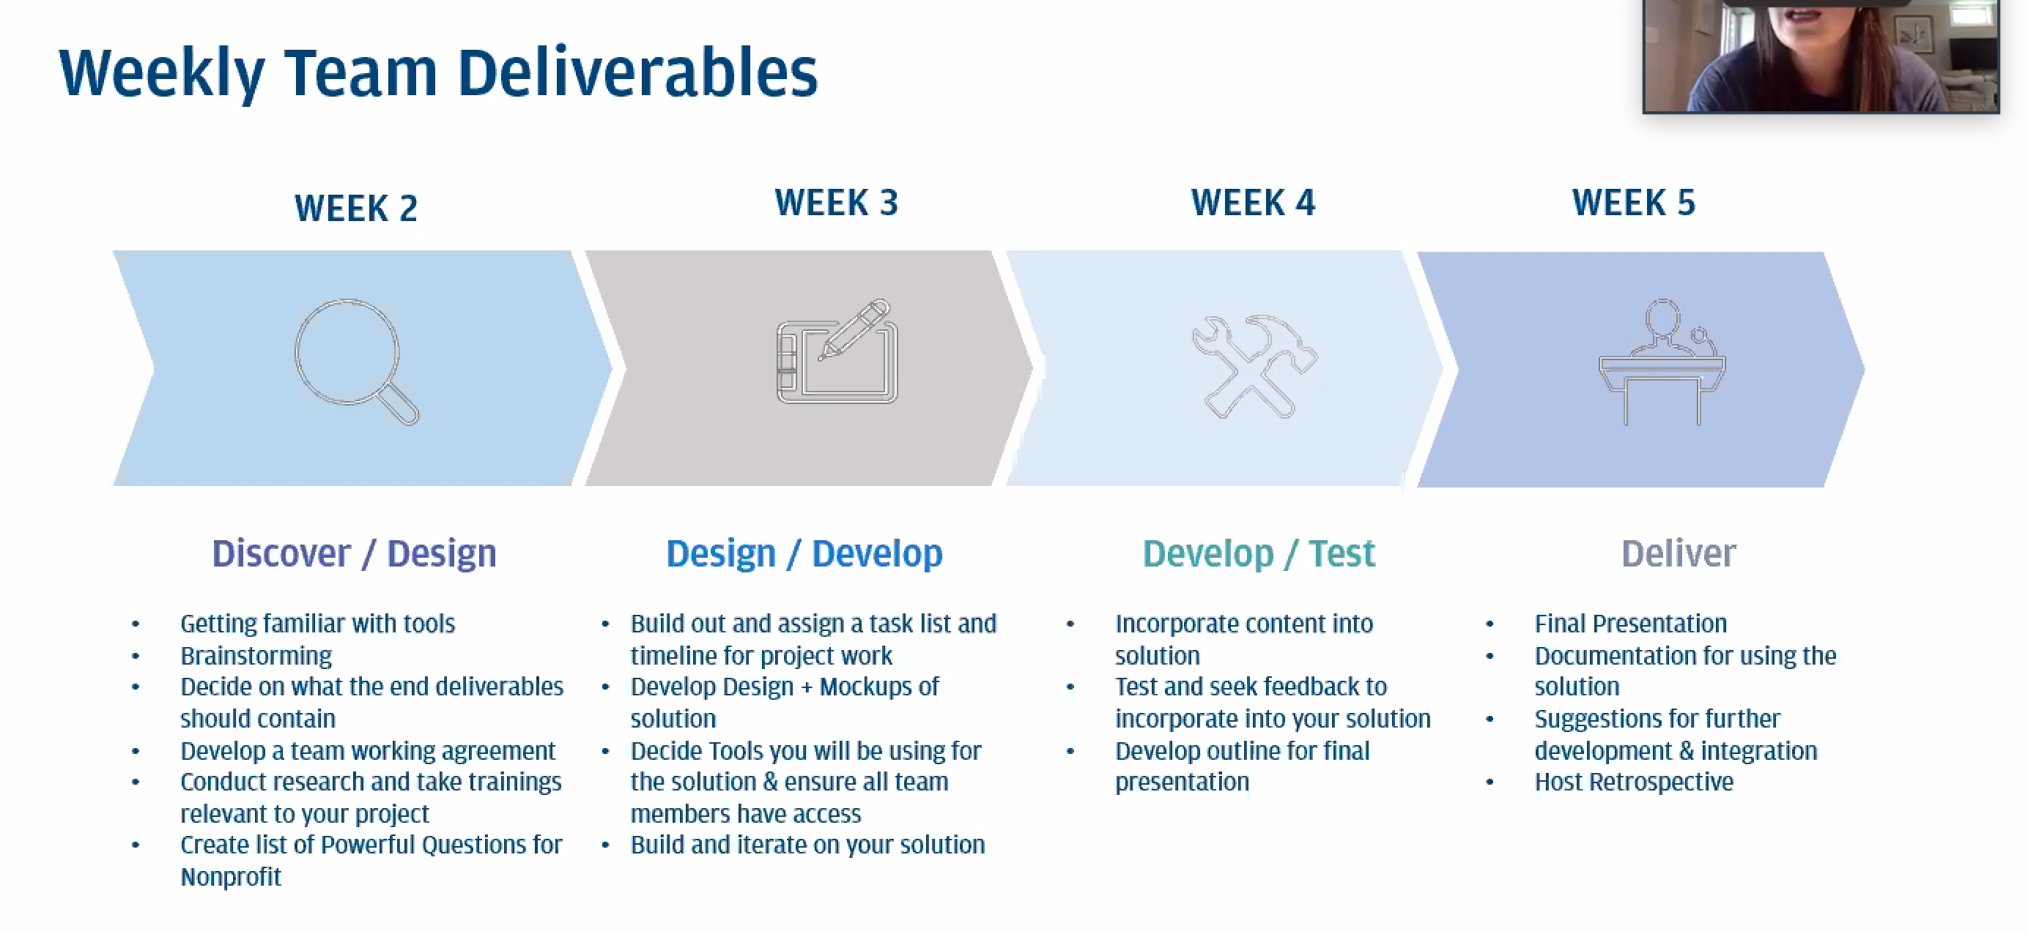

**Meeting with Alhezheimers: Peter Kelham**

* Roles available: around 12. Fundairsing, awareness raising, providing feedback on oublications produced, office support, speaking out on their behalf, building relationships with business (ie. collection posts), provide feedback to research proposals, comments on political messaging and if it strikes the right tone for people affected by dementia etc, logistics
  + National platform to recruit volunteers: Doit??? They use it too
* Automation of volunteer recruitment:
  + During COVID 19: They have free credits on job board from consultancy
  + **Largely manual process. Peter says hes very interested in automation**
  + Volunteer demographics: white, middleclass, women aged 50+. Ratio of women to men 70:30. They haven’t collected much info on belief and race and will do so later in the year.
  + What info do they currently ask from volunteers signing up? How they found out? Whar skills and expericene and they have? Do they work with corporate partner (so that they know if they can strike up a partnership? Headshot phot
    - They don’t ask about age, beliefs or race. They don’t necessaerily have need to collect more info, which is why they haven’t done so. They are open to though if it can help them to engae with volunteers on a ‘deeper’ leve.
* Which activities are volunteers involved in virtually?
  + Information review (ie. health info)
    - People reading scientific research
* Are roles flexible?
  + They haven’t invested in any sort of matching. They wish to invest in that more. Applications state interests etc, so that can be used
  + Applications are structured such that volunteers apply to a specific opportunity rather than a volunteer in general. Right now, itss difficult to express an interest in multiple things. The wants to be able to broaden volunteer involvement.
* Do you have a tech team? Developers? Do you outsource?
  + They liaise with tech companies. They have data teams that work in partnerships with tech companies. Chairty of about 200 and a handful of people that fit into that.
  + It appears that they don’t have a dedicated tech team. They outsource tech solutions.
* How is cruitment done?
  + Solely via their site. They then use racersedge (CRM?)
* Stakeholders for challenge:
  + Him and hisss immediate team.
* They plan to use digital onboarding in the future and wish to use tech to make onboarding experience more ‘personable’
* They hope to have decided key pillars/vision for volunteering within 4-6months. They still want to decide which volunteering roles they want to have. They want to redesign structure. Are the volunteers roles aligning with the work they want to do?
  + He believes that volunteer are yet to play a crucial role in attaining their 2025 vision
* Community speser roe

Determine what we each want to develop and put in portal

* Determine the issue you want to fix and how your technology solves this problem.
* Every button etc.

Jamie Dimon:

* Govt alone cant do it
* People let back the most are black community. His commitment to help black people
* 150 years since civil war, no where near parity.
* 1. It is the right thing to do
* 2. Better business
* Use of AI in reverse bias
* Increase in women from ethnic minorities

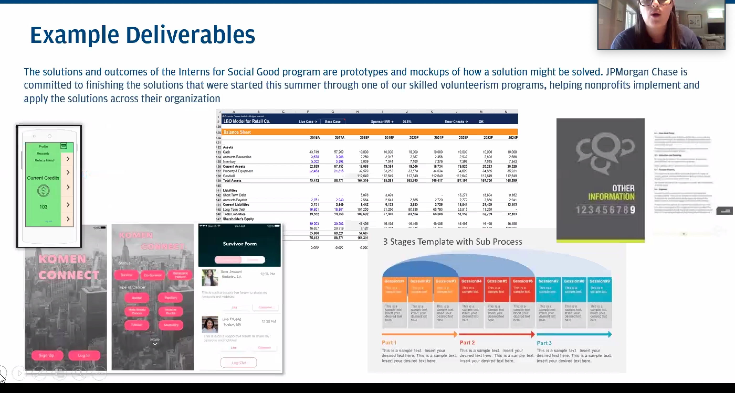

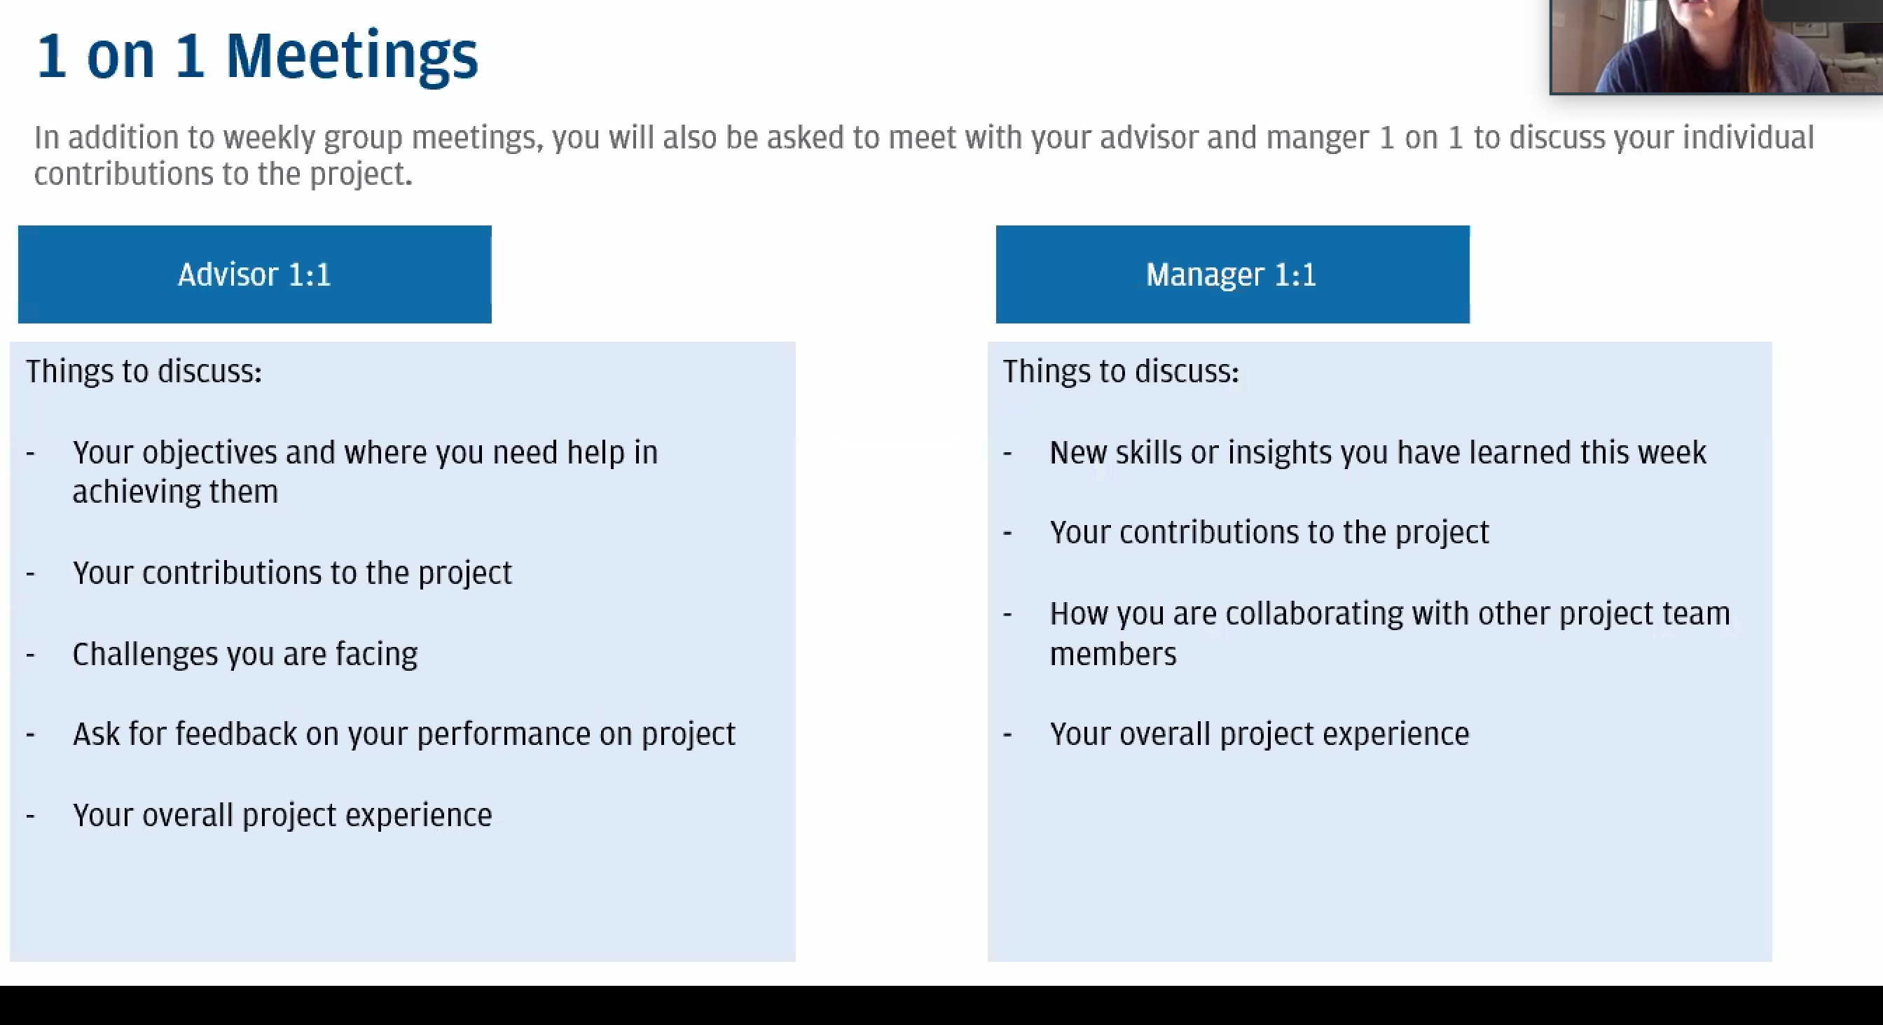

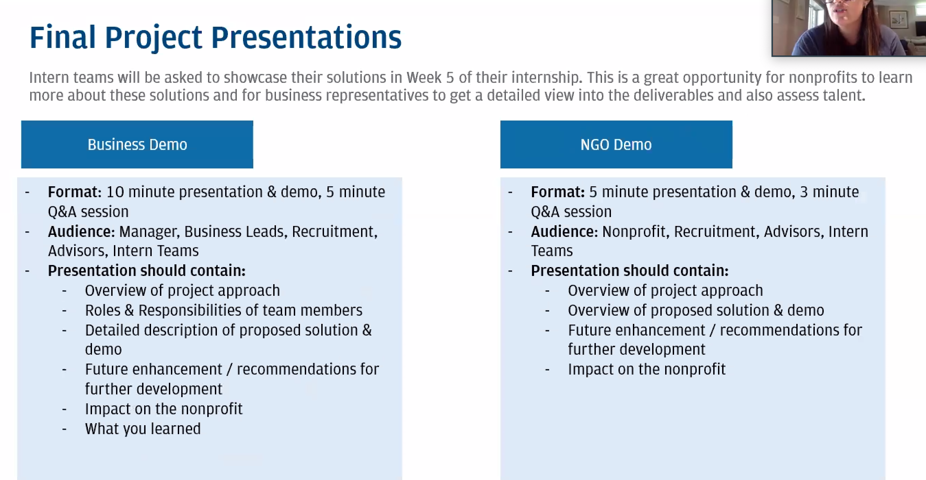

**Go/i4sgemea**

**GENERAL INFO:**

**Inside Sherpa:**

* Self reflection video for each completed module
  + To show manager how you came to solution
  + And to discuss challenges faces
* Modules open Monday 7am and close Sunday 11pm
* Can ask your manager if they have encountered any of the technical themes covered in that weeks module. Must discuss connection between module theme and work done in the bank.
* **Completed modules should be discussed with manager. ASK FOR FEEDBACK OR AREAS OF IMPROVEMENT FOR NEXT MODULE.**
* **If there are any modules you find interesting, tell manager and ask about roles containing those topics**

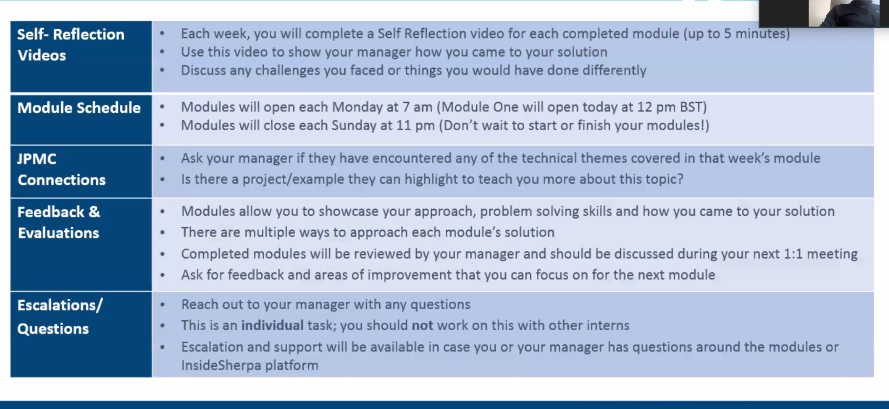

**Agile:**

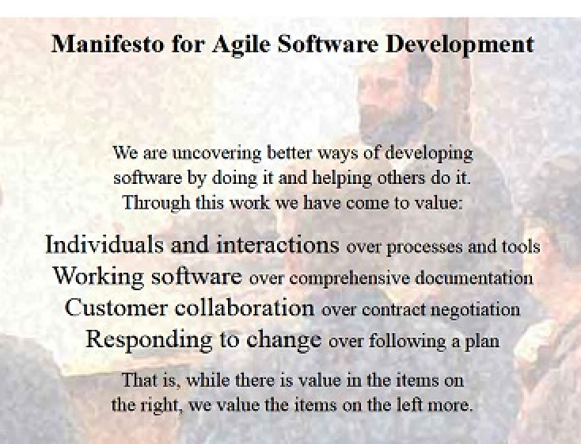

**Securecode:**

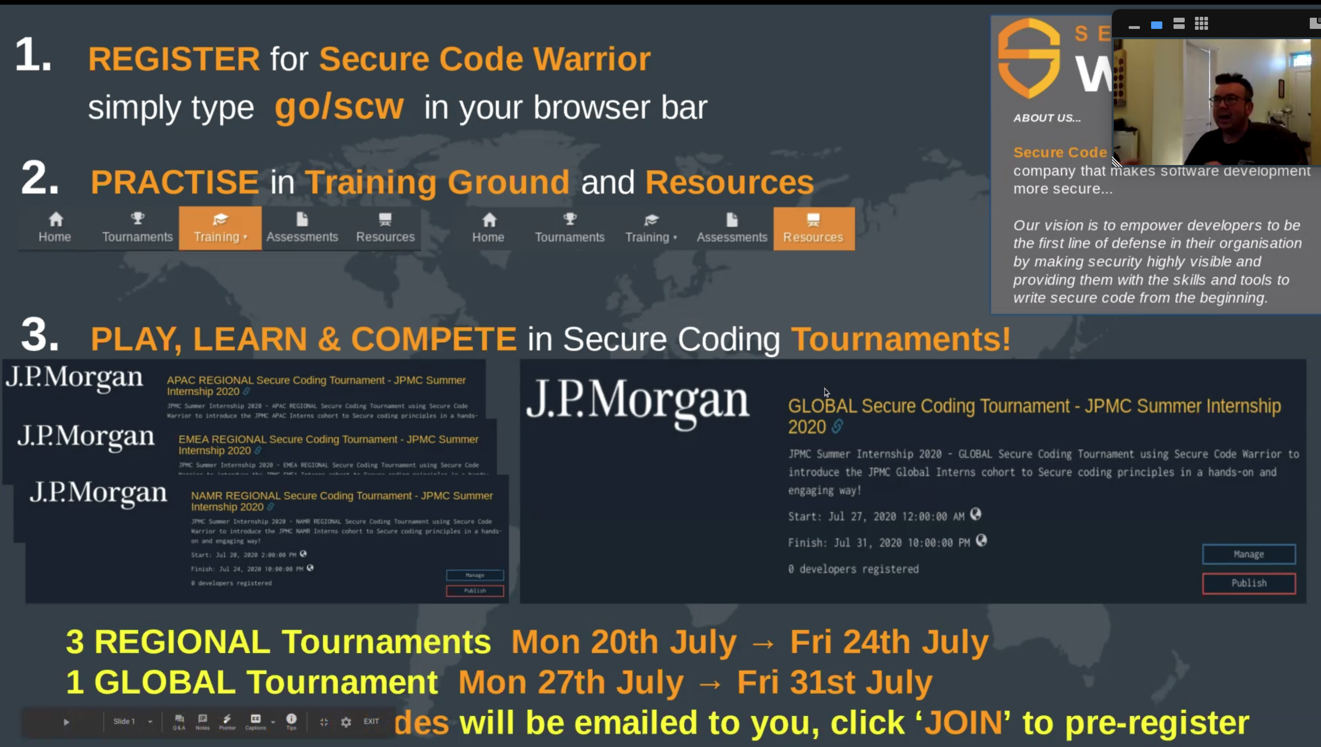

**PROJECT DIARY:**

**CONVERSION TIPS:**

Monday 6th Jul:

* Any piece of work done, ask for feedback!!
* Create a list of people to reach out to. Ask analysts who I should speak to.
* Email manager daily or weekly. Ask them what work for them best in regards to keeping them updated. THIS IS IMPORTANT TBH.
* Must appear motivated (in eyes of manager) all the way through, so that by the end it does not look like I am uninterested
* Getting an offer shouldn’t be a mystery until last day. Getting constant feedback from manager is important so that you know what your chances are
* Ask lots of ques

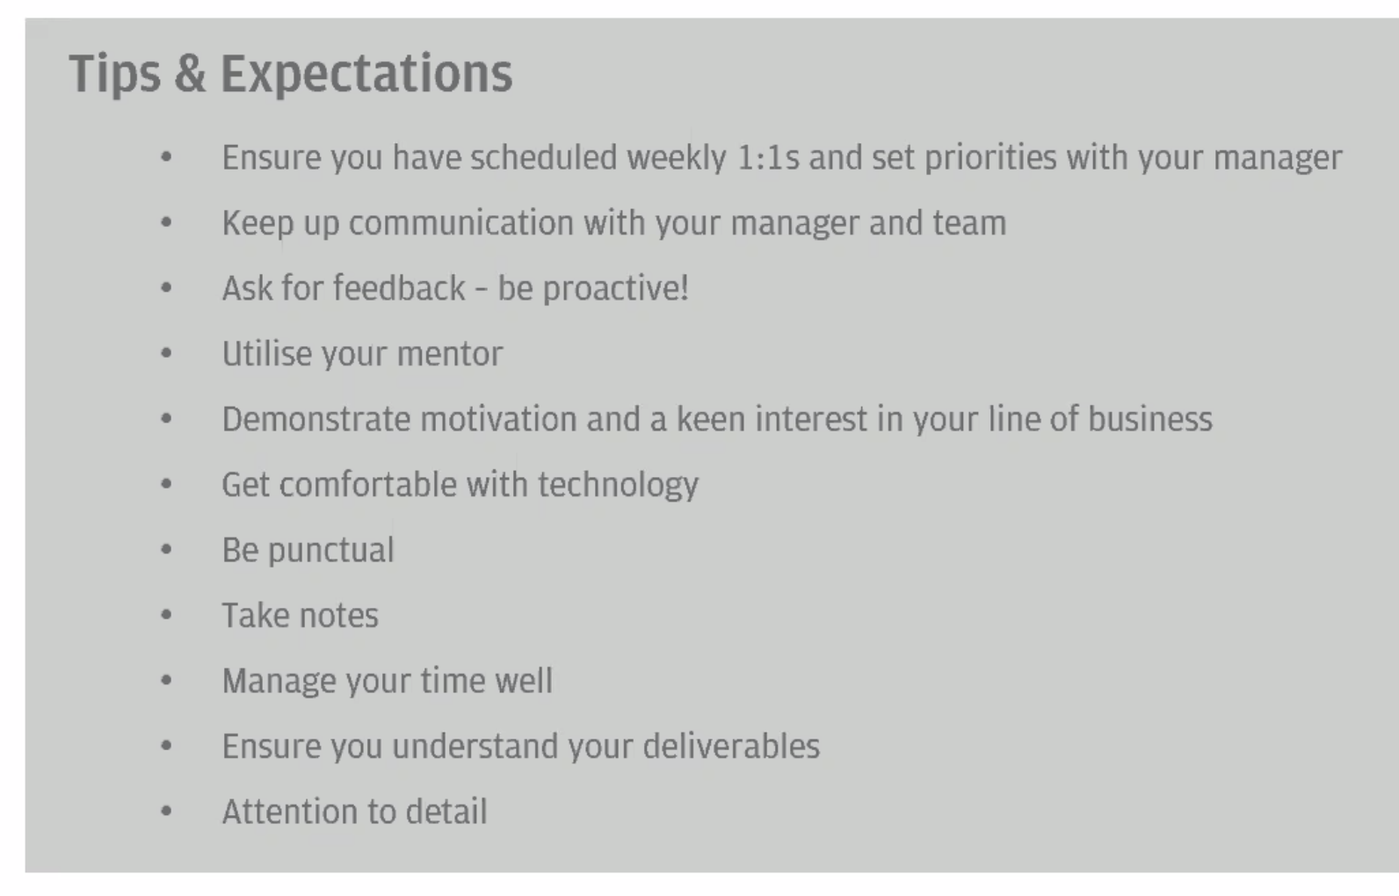

When meeting with manager, competencies should fall under the components in the matrix:

